SIMATS ENGINEERING
ASSESSMENT TOOL 1

COURSE NAME: Artificial Intelligence COURSE CODE: CSA17
COURSE OUTCOME COVERED

CO1: Apply AI basics such as intelligent agents and uninformed search methods to
solve problems effectively. (BL3)
Assessment Tool Weightage: 50%
QUESTIONS: 5 Duration : 1 Hour
Total Marks:50

Annexure A
Analytical Problem Solving

Code of Conduct:
I Shaik mahamad Sohail (192511120) certify that this submission is my original work
and that I have adhered to the guidelines specified for this assessment.
I understand that any violation of academic integrity rules will result in disciplinary action.
Signature of the student:

Annexure A
Analytical Problem Solving

1. Solve the Water Jug problem: you are given 2 jugs, a 4-gallon one and 3-gallon one.
Neither has any measuring maker on it. There is a pump that can be used to fill the
jugs with water. How can you get exactly 2 gallons of water into 4-gallon jug?
Explicit assumptions: A jug can be filled from the pump, water can be poured out of a
jug onto the ground, water can be poured from one jug to another and that there are
no other measuring devices available.

2. Find out how Mars Rover, analyse and explore the samples on Mars by answering the
following questions.
i. What are the percept’s for this agent?
ii. Characterize the operating environment.
iii. What are the actions the agent can take?
iv. How can one evaluate the performance of the agent?
v. What sort of agent architecture do you think is most suitable for this agent?
Why?

3. Explore the search space using search strategies and formulate the problem
components for the 8-Queens problem using the following information: Place 8
queens on a chessboard such that none of the queen’s attack any of the others. A
configuration of 8 queens on the board as shown in the figure below, but this does not
represent a solution as the queen in the first column is on the same diagonal as the queen in the last column.
4. A customer wants to travel from the one location to another location using OLA Cab
booking mobile application. The customer can select the any of the cab type as mini,
micro, sedan, shared, prime and so on based on his comfort to reach the destination.
Identify what type of problem-solving agent can be used and write the pseudocode
for the above problem.

5. A logistics company operates a delivery network where packages must be transported
between warehouses at minimum cost. Each route between warehouses has an
associated travel cost (fuel + time). The company wants to determine the least-cost
path from the starting warehouse S to the destination warehouse G using the Uniform
Cost Search (UCS) algorithm.
The delivery network is represented as a weighted graph:

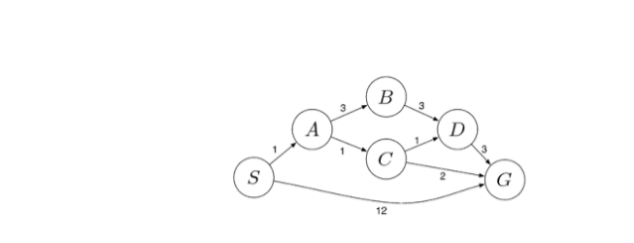

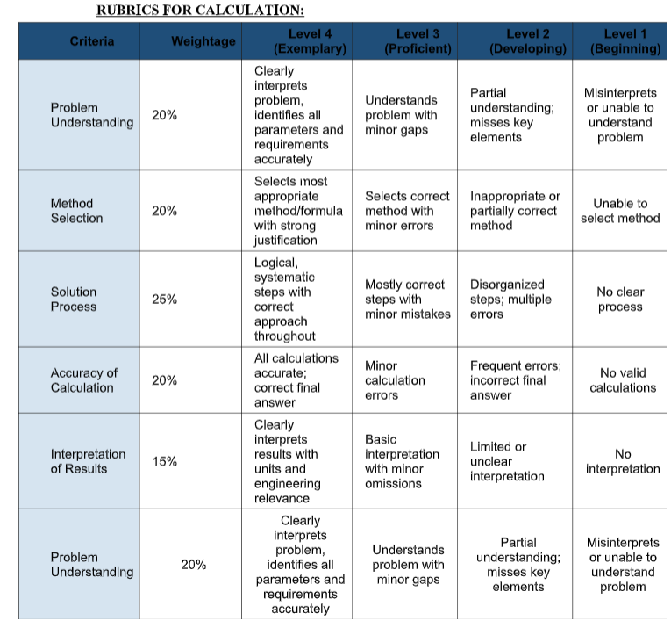

1. Water Jug Problem (4-Gallon and 3-Gallon Jugs)
State Space
Represent each state as (4-gallon jug, 3-gallon jug).
Initial State
(0,0)
Goal State
(2,0) (Exactly 2 gallons in the 4-gallon jug)

Steps to Reach the Goal
Step | Action | State 4G,3G
1 | Fill 3-gallon jug | (0,3)
2 | Pour 3G → 4G | (3,0)
3 | Fill 3-gallon jug again | (3,3)
4 | Pour 3G → 4G until full | (4,2)
5 | Empty 4-gallon jug | (0,2)
6 | Pour 2 gallons into 4G | (2,0) ✔

Goal Achieved : Exactly 2 gallons are in the 4-gallon jug.

2. Mars Rover Agent
i. Percepts
- Images from cameras
- Rock and soil composition
- Temperature
- Atmospheric pressure
- Terrain obstacles
- Position (GPS/Inertial sensors)
- Battery level

ii. Operating Environment
- Partially Observable
- Deterministic
- Sequential
- Dynamic
- Continuous
- Unknown

iii. Actions
- Move forward/backward
- Turn left/right
- Capture images
- Drill rocks
- Collect soil samples
- Analyze samples
- Send data to Earth
- Recharge using solar panels

iv. Performance Measure
- Number of successful samples collected
- Accuracy of scientific observations
- Distance safely traveled
- Energy efficiency
- Successful communication with Earth

